**React Vs Next Js –**

**Fundamental difference –**

**NextJs app is SSR (Server Side rendered app) –**

If you view page source of next js app then you will get full page already rendered (it helps in SEO).

But in react app theres a root div and the content gets rendered there in client side by js.

**Catch all routes in Next Js –**

**To catch all routes in next js create a folder with this syntax – […filePath]**

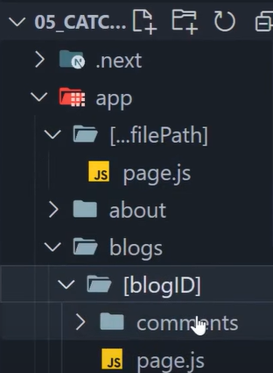

**Then inside it create page.js file and in this page.js file you will get an array of params containing all the params –**

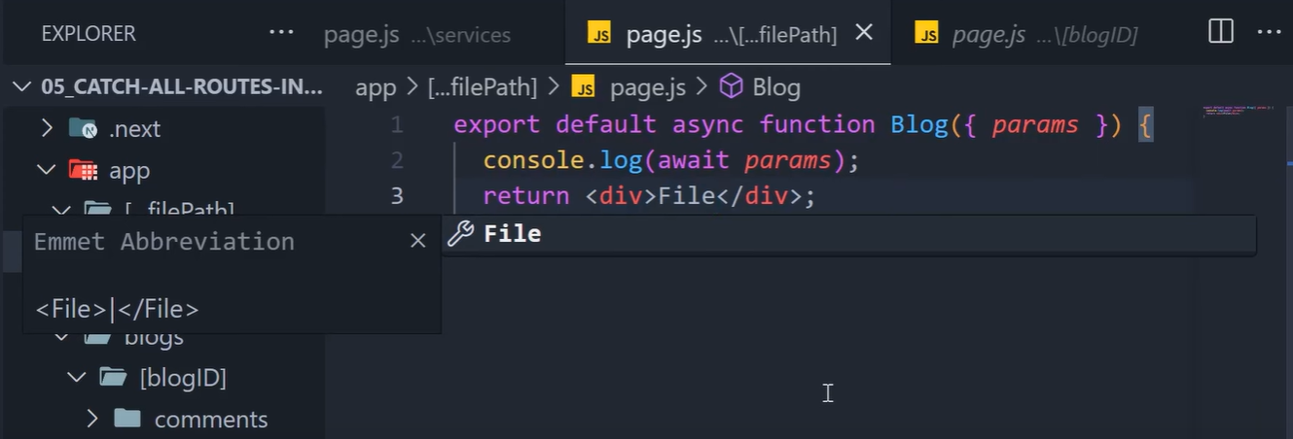

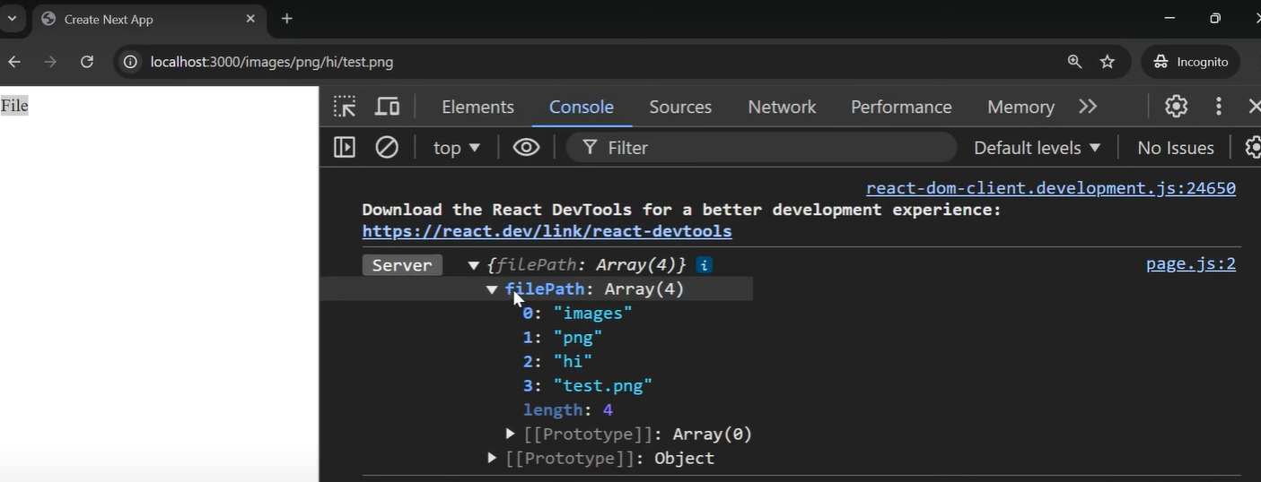

**If you have already made a path then that path will work how you have made it but if you haven’t defined a path then you will get it here.**

**The traditional way to use catch all paths is by using it under a folder called file –**

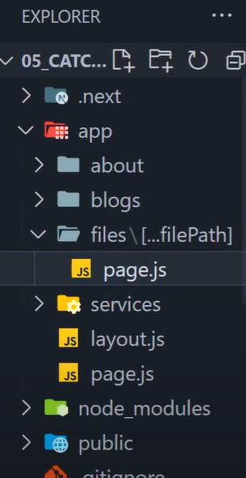

**So it will work only on path starting with file as it is mainly used to serve a file.**

**Optional catch all route –**

**To create a optional catch all route page you can put the […filePath] in one more [] – [[…filePath]] –**

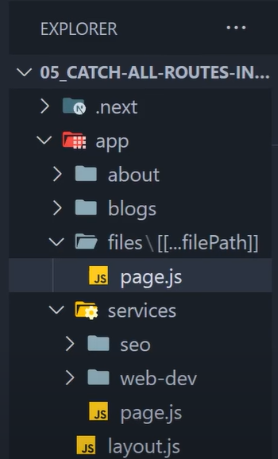

**What this will do is serve the page.js file if the user enters on just /files (cause now …filePath is optional so that means if there is no params after file then the page.js file will be served for files folder.**

**Note – we cannot use optional catch all route on root level because it will conflict with the root folders page.js file.**

**Reusable layouts in Next Js –**

**You can create a layout.jsx file in every route that renders before page.tsx**

**Custom not-found page –**

**To add a custom not found page in next js you need to create a component name not-found.tsx and then you can use is anywhere using notFound() function in next js –**

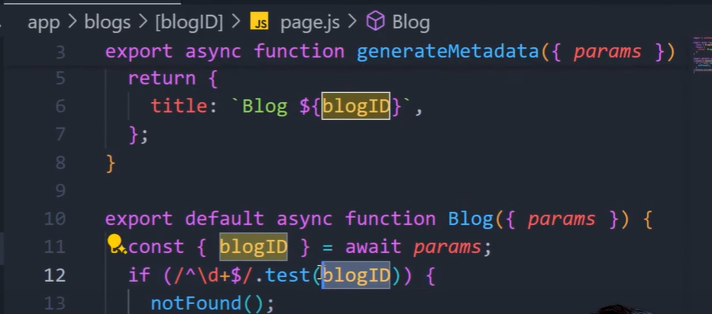

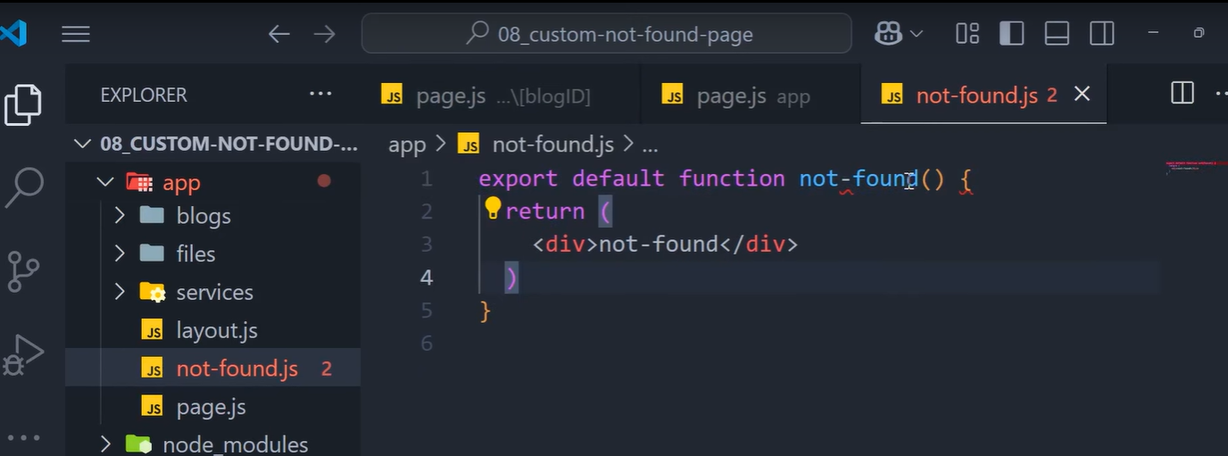

**You can create custom not-found pages for custom routes by making a not-found.tsx file under that folder or route (we do not get params under this not-found page), however you can do it by making the not-found component “use client” and then use a hook called usePathname()**

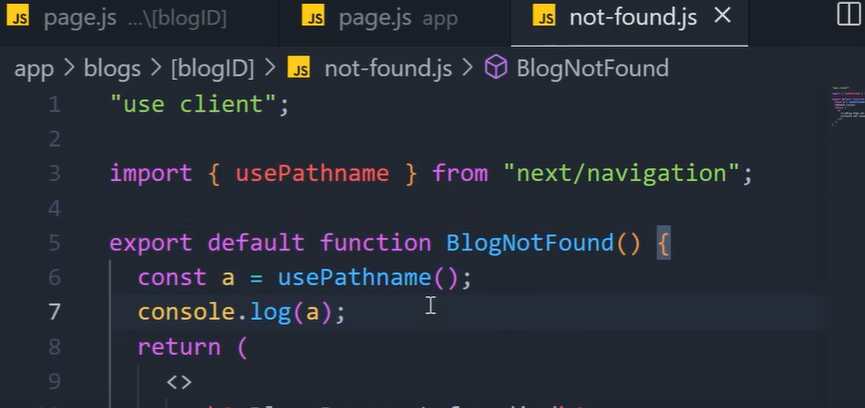

**Routes Group in Next JS –**

**Used to group routes in a single folder without adding that folder to the path**

**It is done by adding the group folders name inside paranthesis () –**

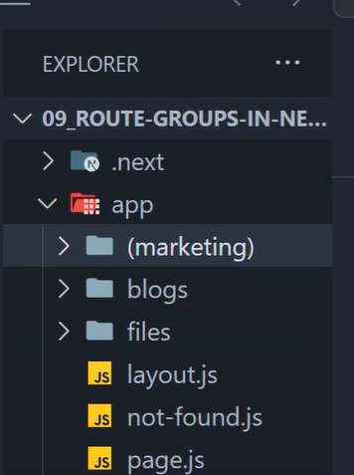

**You can make custom layouts for group routes like this –**

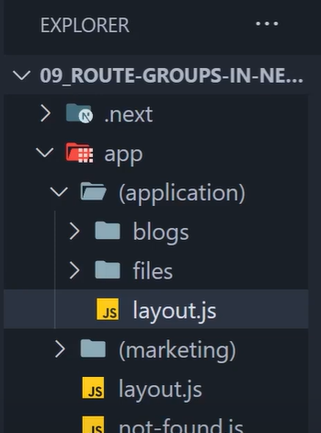

**Private folders in Next JS –**

**If you don’t want to serve a folder by page.tsx file then you can make that folder private by adding a underscore before the folder name -**

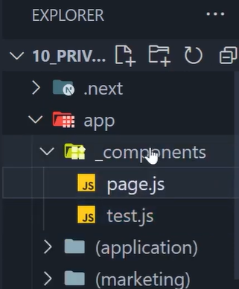

**Next JS wont serve this folder as routes**

**However just in case you want to make a route with underscore in beginning you can use %5F –**

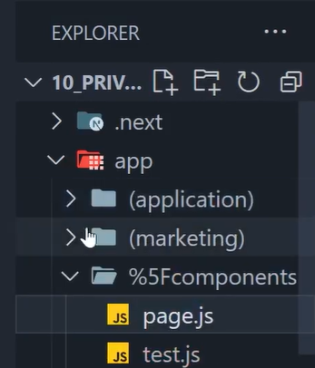

**Now this is a public route with _underscore in beginning**

**Rendering Paradigms in Next JS –**

**Where the html file of our app can be generated?**

1. **Server – back then it was the traditional way**
2. **Client – popularized by client side rendering frameworks like Angular, React, vue, etc. (around 2009-10)**

**Drawback of client side rendering is seo optimization**

**Next JS combines SSR and CSR.**

**SSR consists of Server Site Generation (SSG) and Incremental Site Regeneration (ISR)**

**Static Site generation –**

**Frequently visited pages generates at build time**

**Done using function generateStaticParams() –**

**(all this code is in the blog page.js)**

**(All these things work only on production mode(build))**

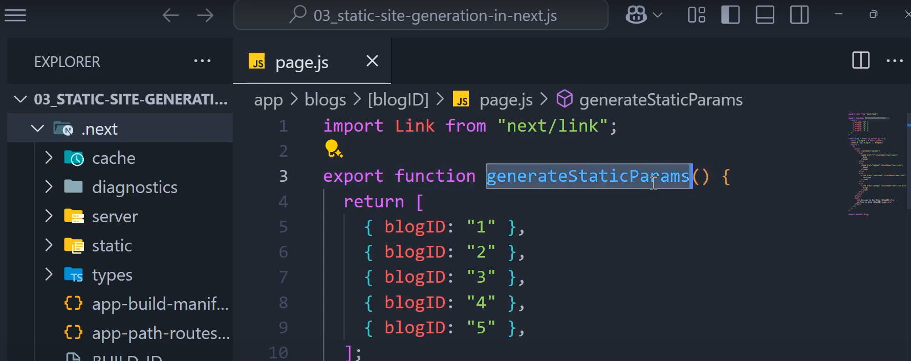

**So Next Js will make these pages as build time for faster processing**

**It is signified using the filled dot symbol in console while building –**

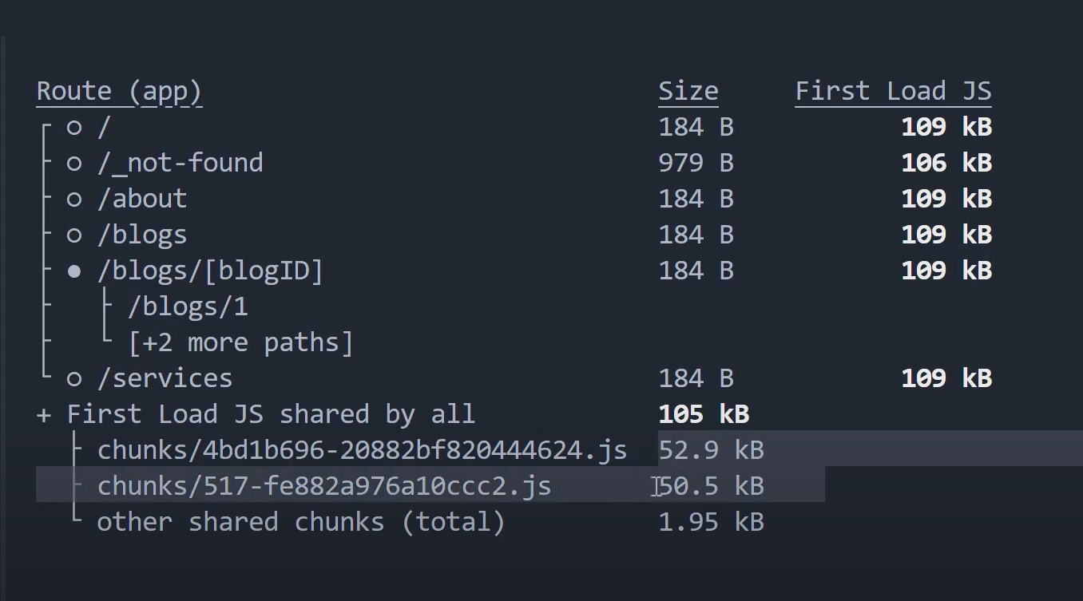

**After building, next folder has these files already generated –**

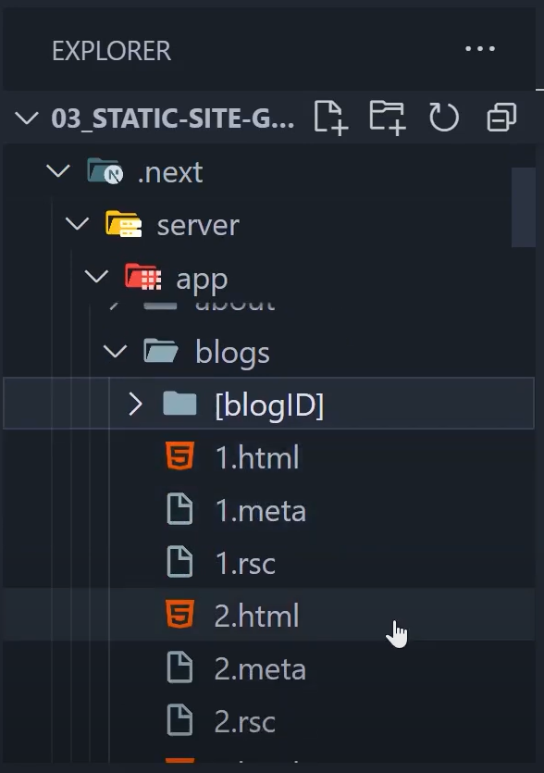

**But here we hard coded the page values, but in practical we usually get the data from database and create the pages**

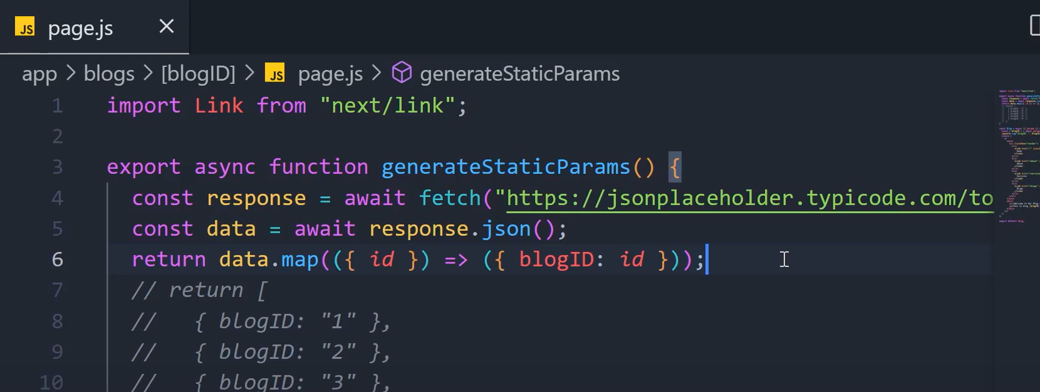

**Here the api returns 200 pages and Next JS makes these 200 pages while building**

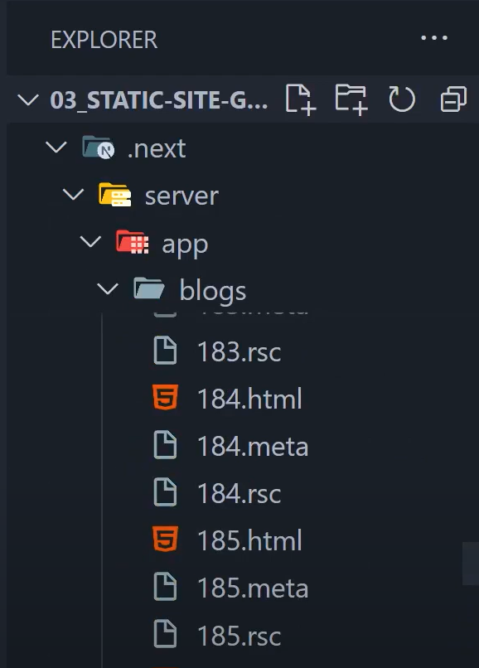

**Dynamic params in static site generation –**

**If the user visits a page that is not statically generated then the server creates that page and serves it, but if in case you want that the user can only visit pages that are statically generated and other pages should show not found in that case you can use property called “dynamicParams” and set it to false –**

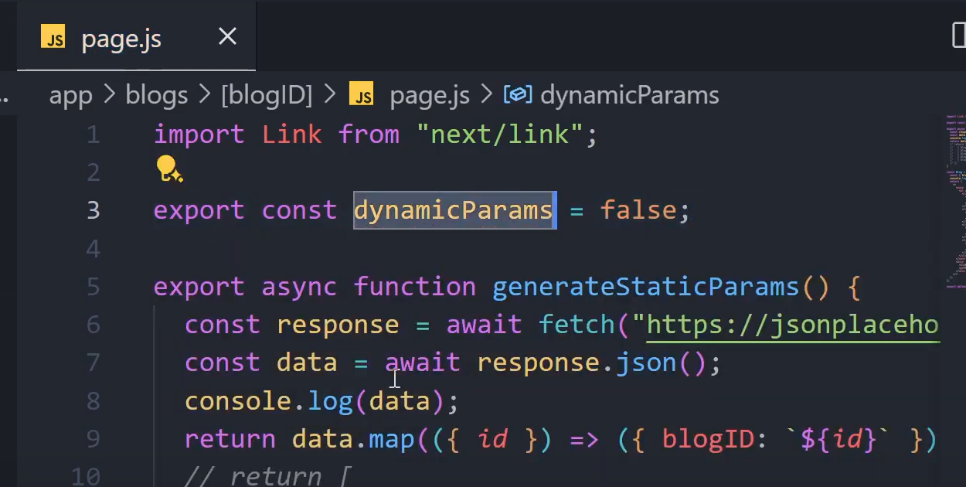

**Incremental Site Generation in Next JS –**

**Incremental site generation means if the user requests a page for the first time in that case only the code will run on server one time if the user req again the same page then it wont run again until next build.**

**But lets say your data in the page is dynamic and changes with time then you can use the property “revalidate” and provide a time interval (default value is false that means never revalidate page) –**

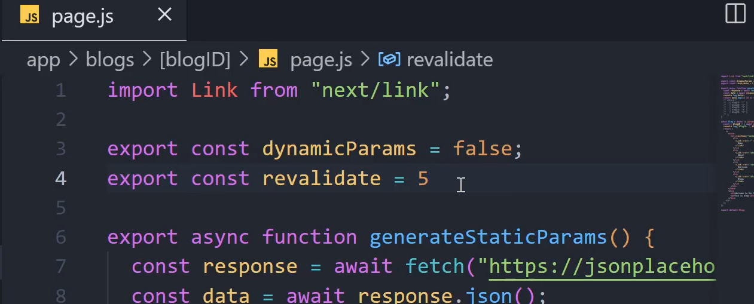

**The value is in seconds means the page will regenerate in 5 seconds to update the data.**

**(again all these things work in production mode only(build))**

**Usecase – lets say the content on your page changes on daily basis, weekly basis or monthly basis then you don’t need to revalidate page in every few seconds**

**How to render static pages dynamically in NEXT JS –**

**You can also render the static pages dynamically like dynamic pages.**

**By default static pages are made during the build process but you can forcefully make them to be generated dynamically using the property “dynamic” and set it to “force-dynamic” (default value is auto) -**

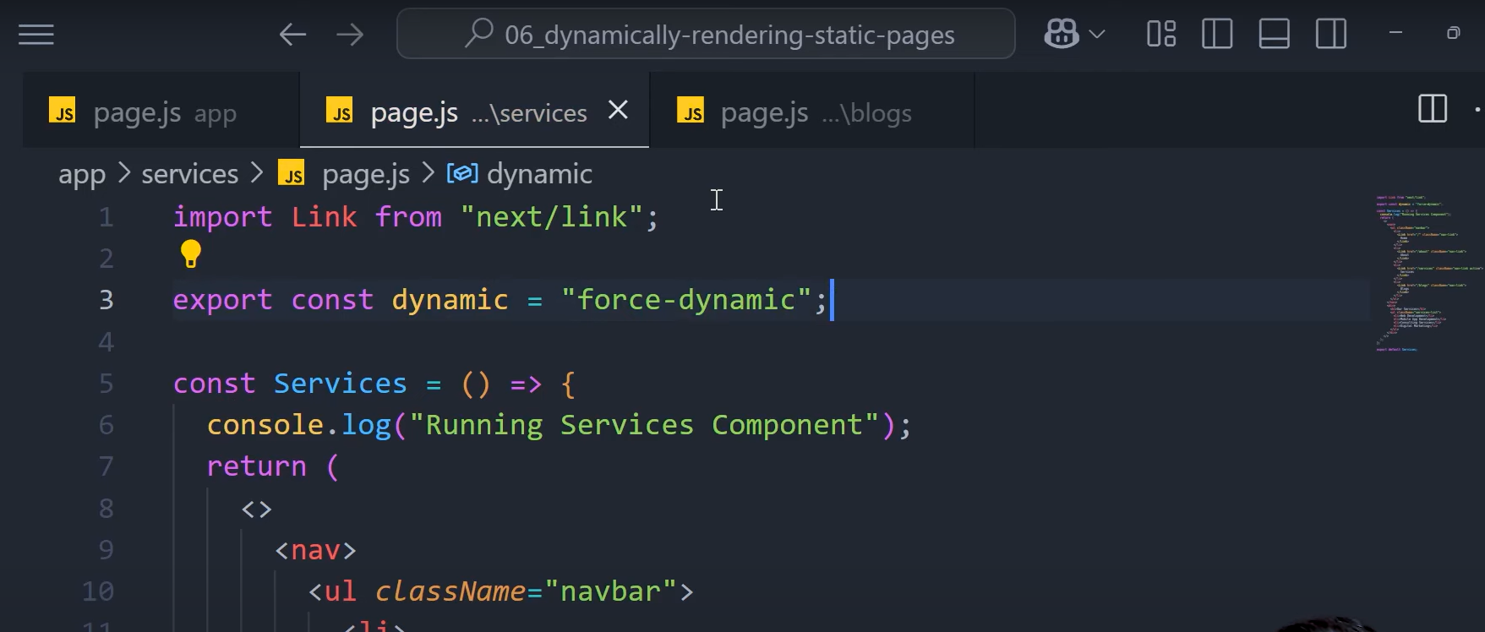

**Now this wont generate the service page while build process –**

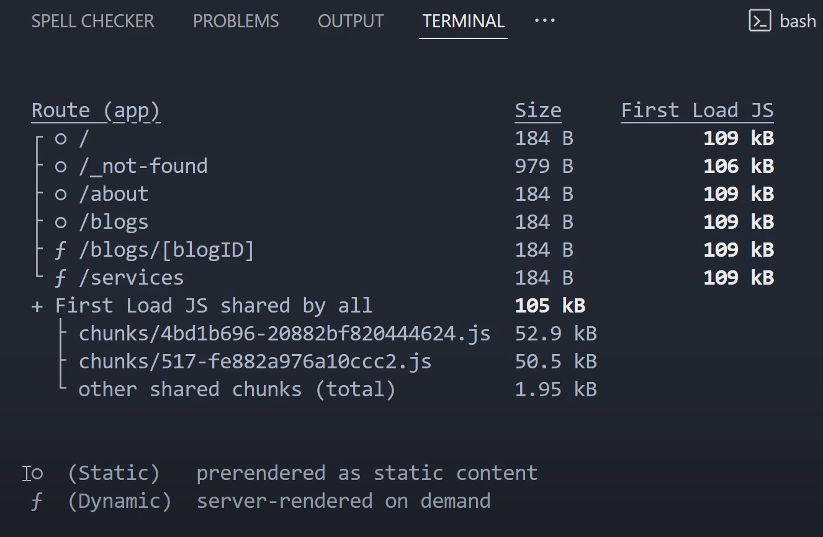

**Empty circles means statically rendered**

**F means dynamic rendered**

**Now what this will do is dynamically generate this server page whenever a request is made.**

**And this is not only the method to dynamic render pages there are more ways like using search params in the function and if you use it in the code then the page automatically becomes dynamically rendered –**

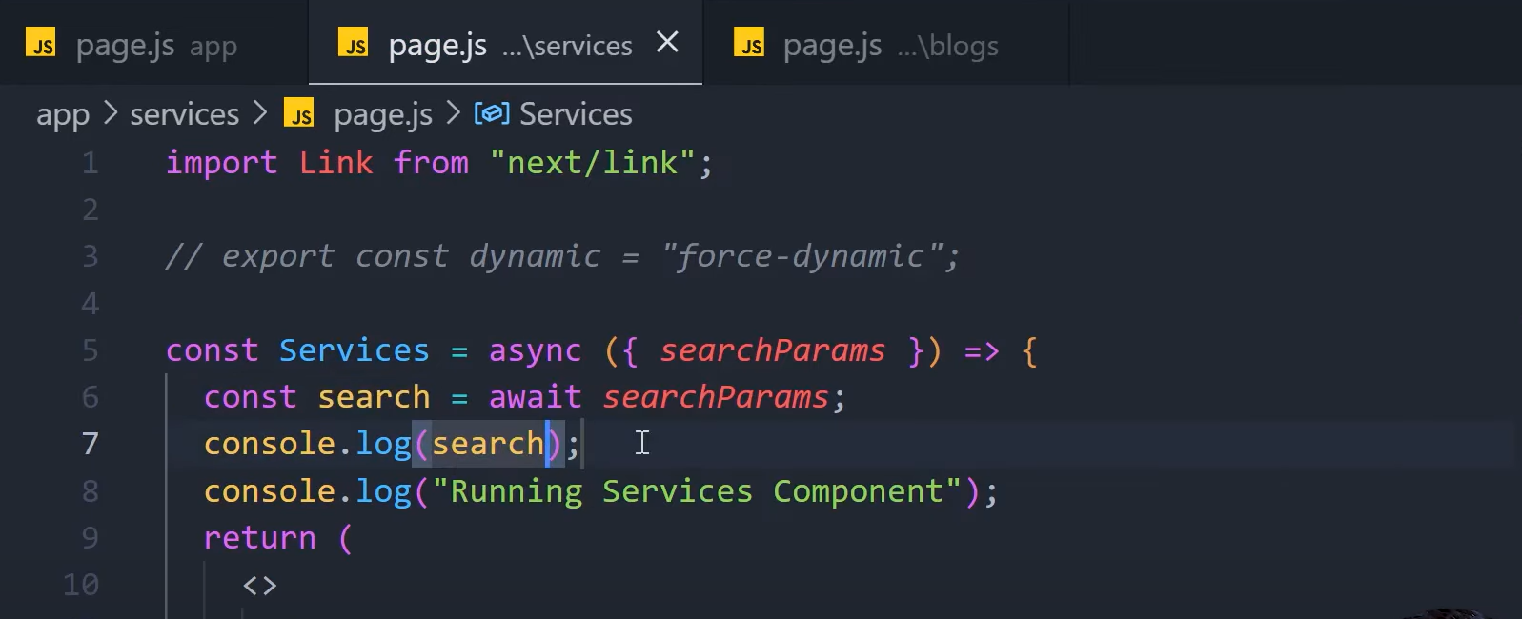

**Other way to do it is using cookies from next headers –**

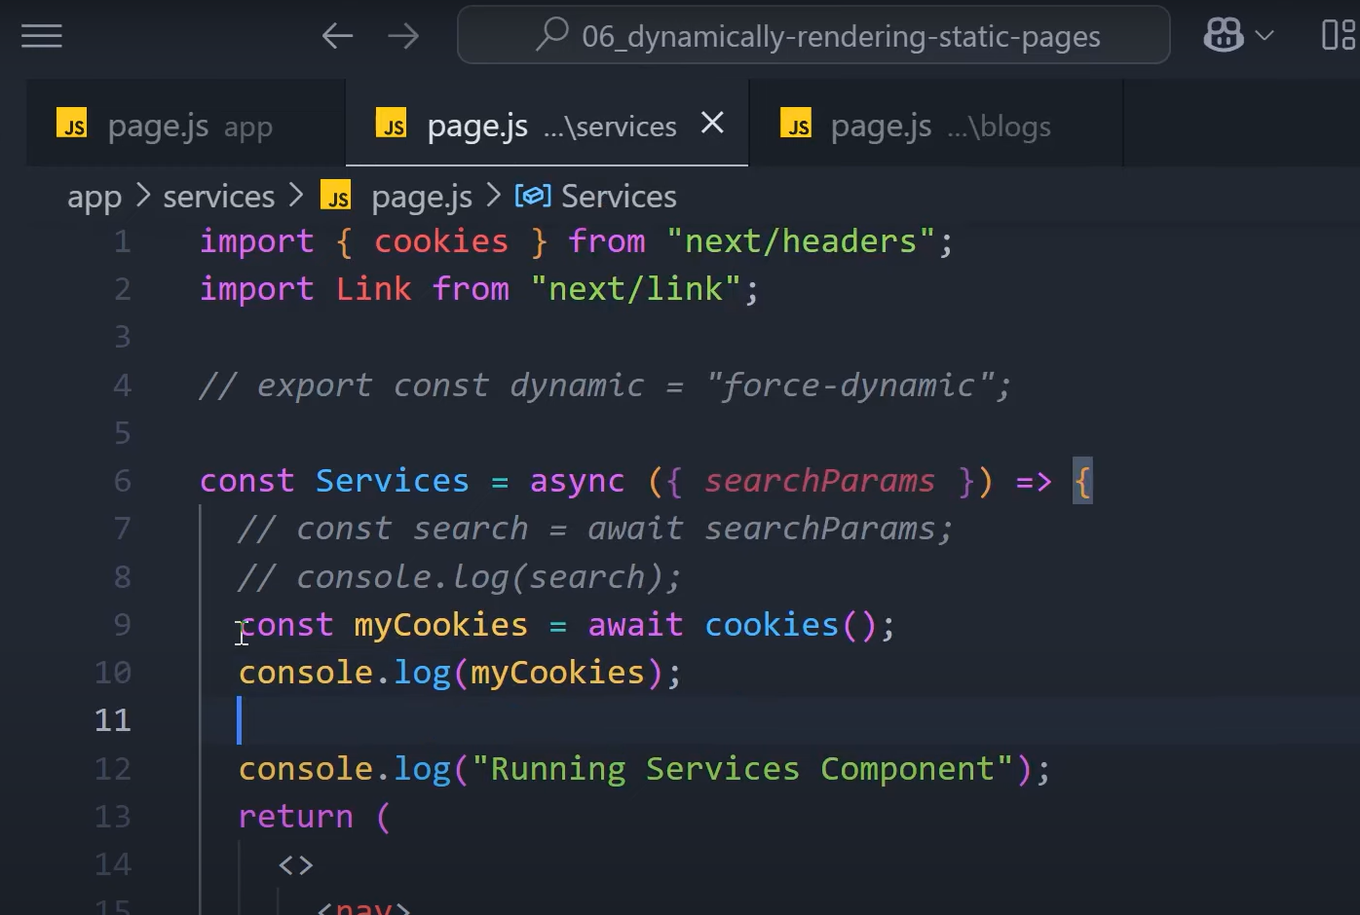

**Other methods to do so are in the documentation –**

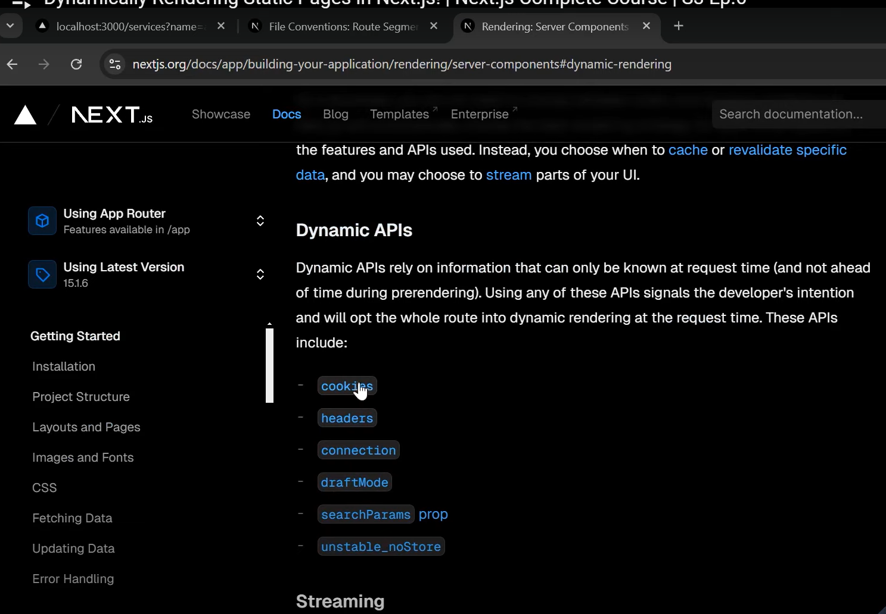

**Streaming in Next JS –**

**This is also rendering paradigm supported by Next JS –**

**If one of the components is doing some asynchronous task for eg. 3 seconds then in that case the page will be rendered in 3 seconds just because of that one component**

**So to avoid this you can stream this component using the “suspense” component from react library –**

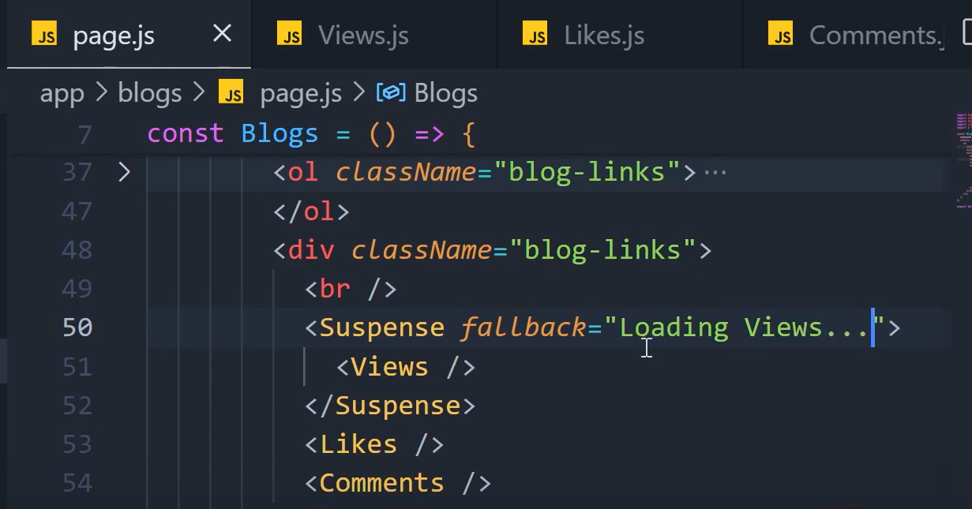

**You can pass anything inside the fallback prop (eg. Html elements) that will be rendered till the component is loaded.**

**Usecase – lets say your page can load in 1 second but some components are making some api calls and need sometime to load in that case you can render loading till that time.**

**Client vs Server components in Next JS –**

**Every component made in Next JS is by default server components means they execute only on the server**

**While the client components render both on server as well as client.**

**We use client components when we need to do some task that can only be done inside browser (eg. Accessing window object).**

**To make a component client component you need to use directive “use client”**

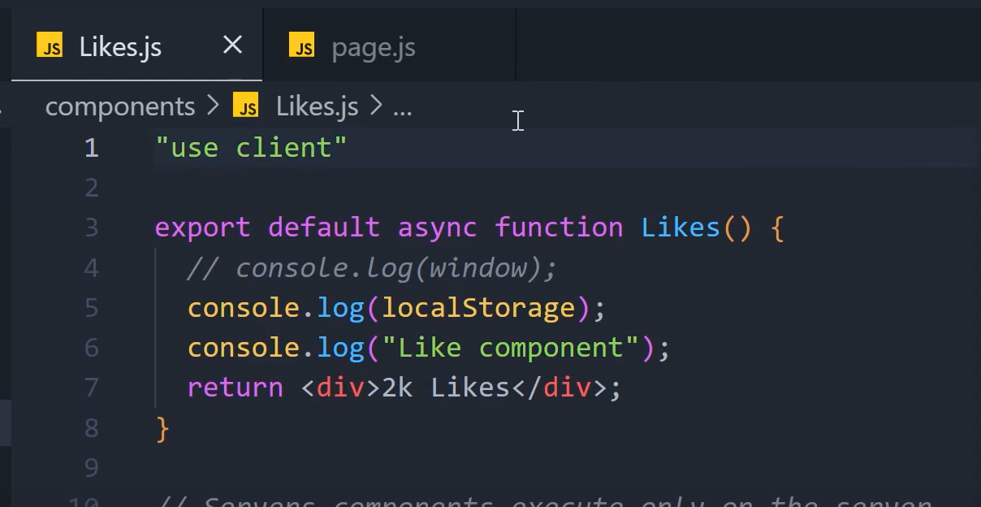

**This will work fine on the client side but will cause a error on server to prevent this you can add a check whether it is undefined, so it wont give error on the server side also –**

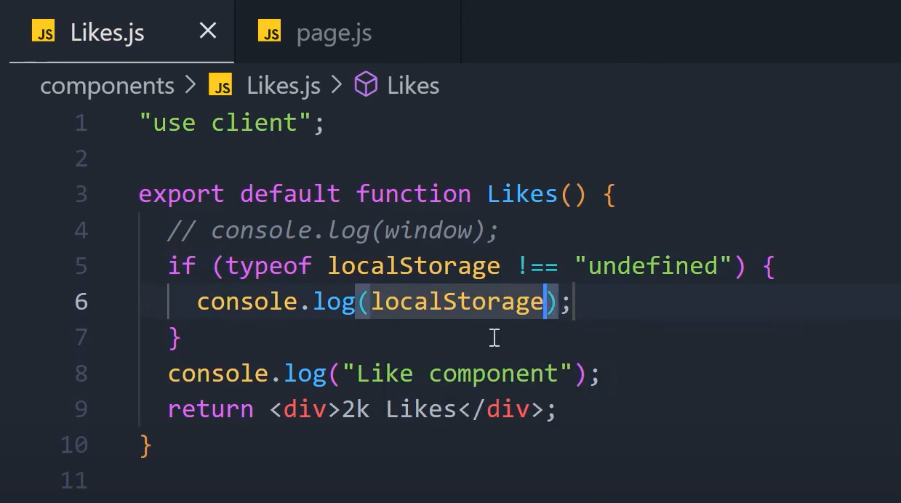

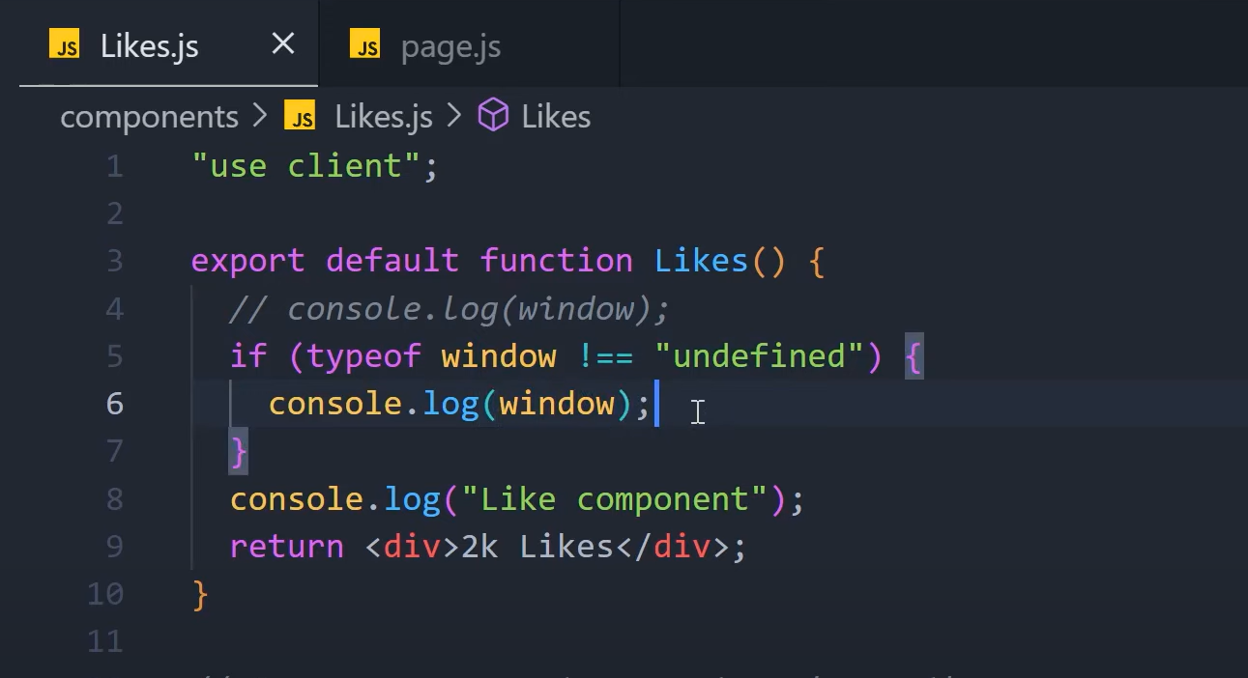

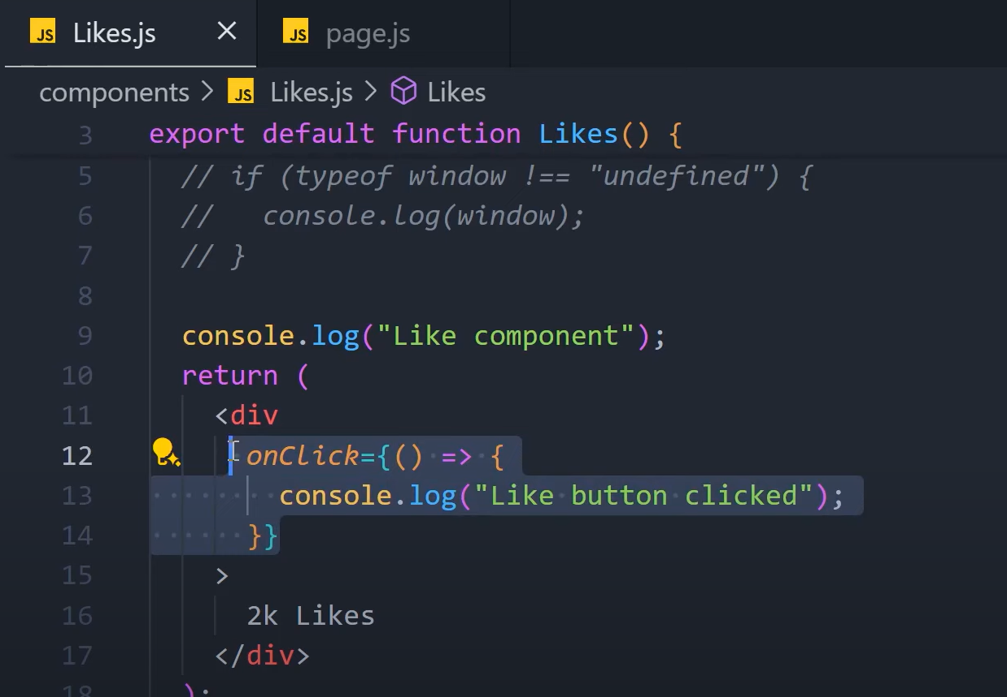

**In this last case Next JS is smart enough to know that onClick don’t needs to be executed on the server.**

**Hydration in Next JS –**

**It is basically the process of adding interactivity to our pre rendered html pages.**

**It ensures that whatever is sent from the server that same thing is getting rendered on the client, and if it doesn’t then it causes hydration error.**

**Server side data fetching in Next JS –**

**Next JS extends the normal fetch api with some additional attributes –**

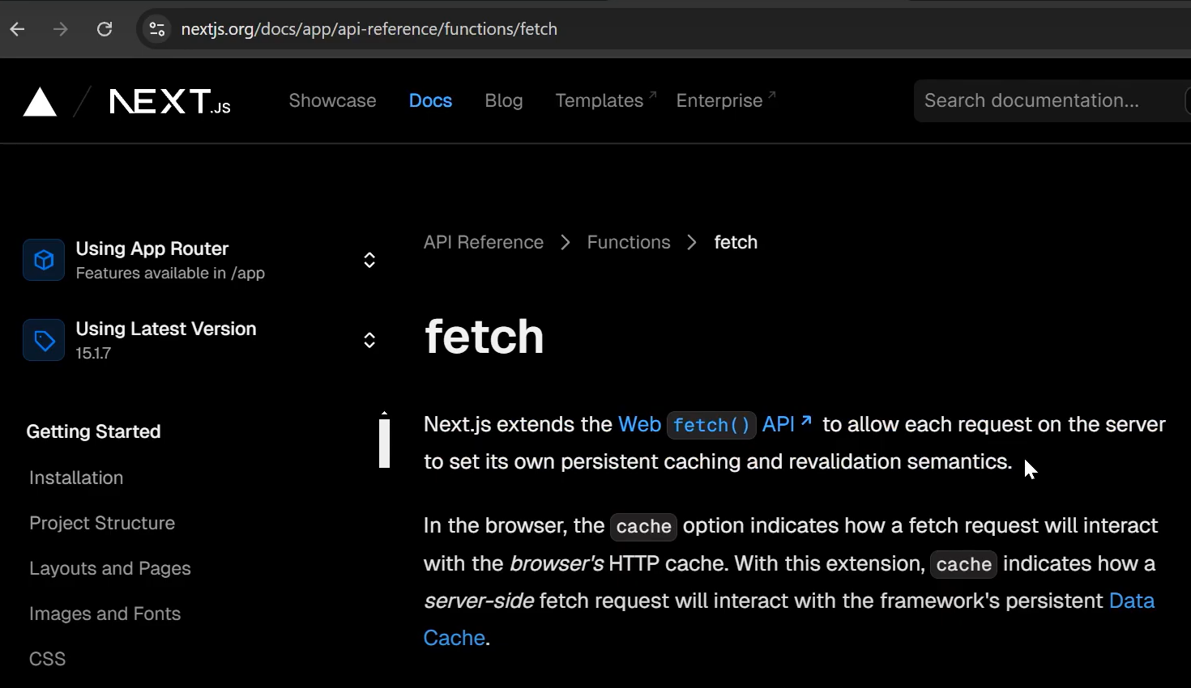

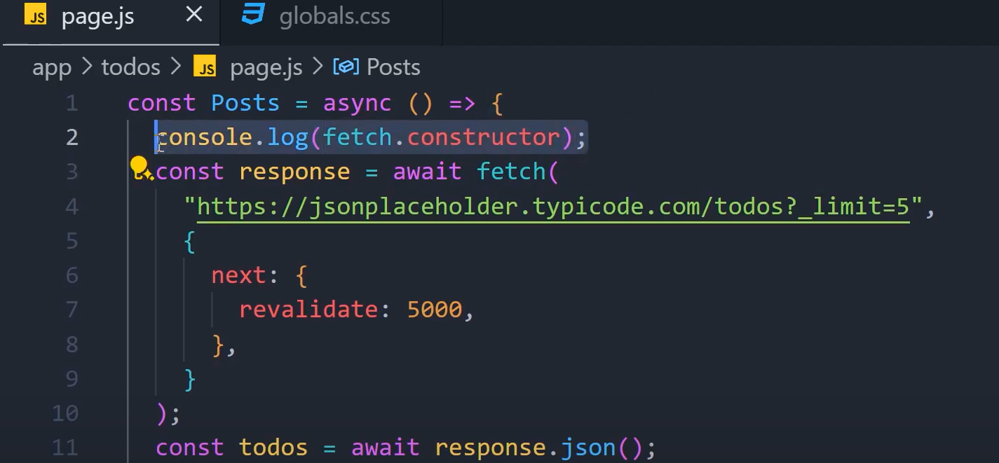

**How to render server components inside client component in Next JS –**

**You can do it by giving the server component as a prop –**

**Code before –**

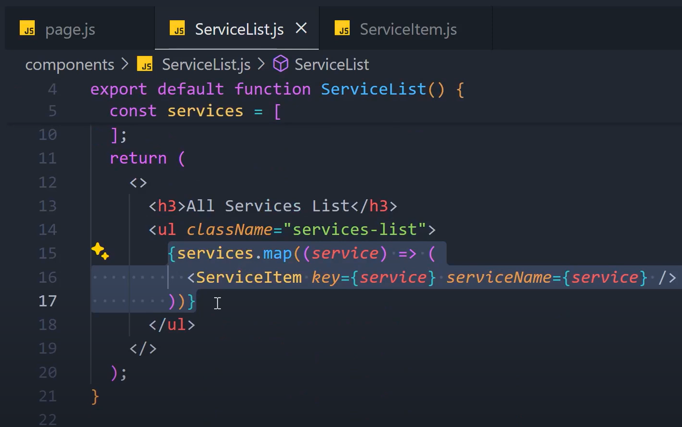

**Code after –**

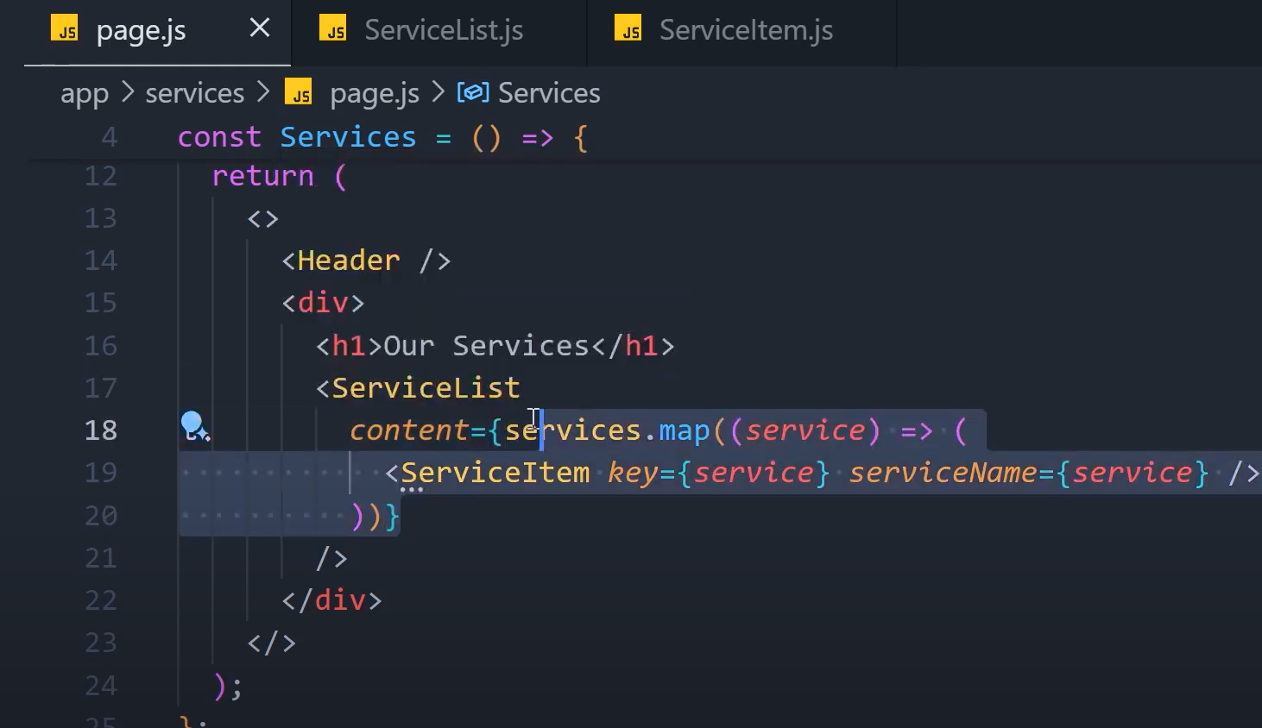

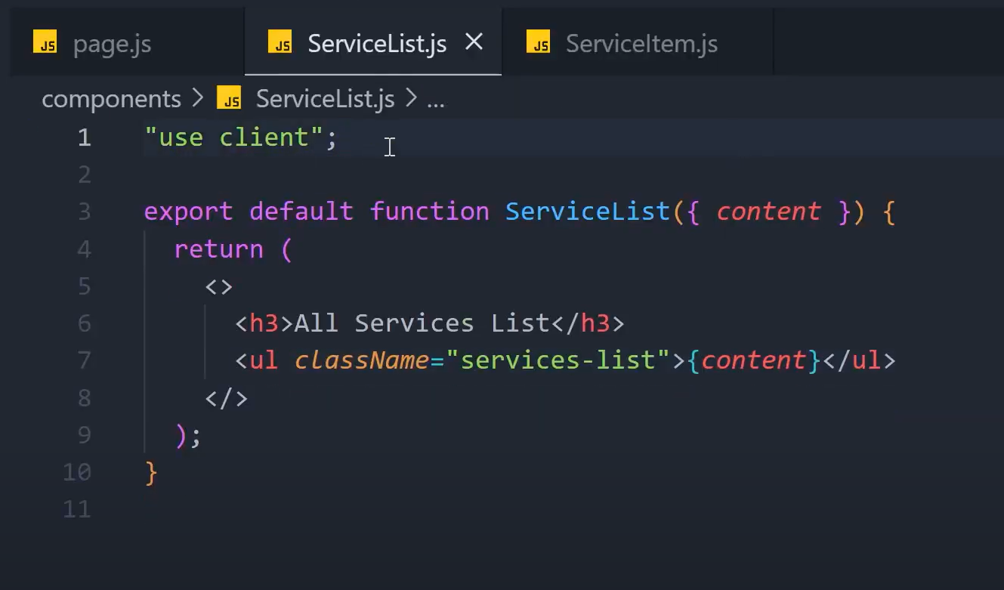

**(also moved the services array to the parent component.**